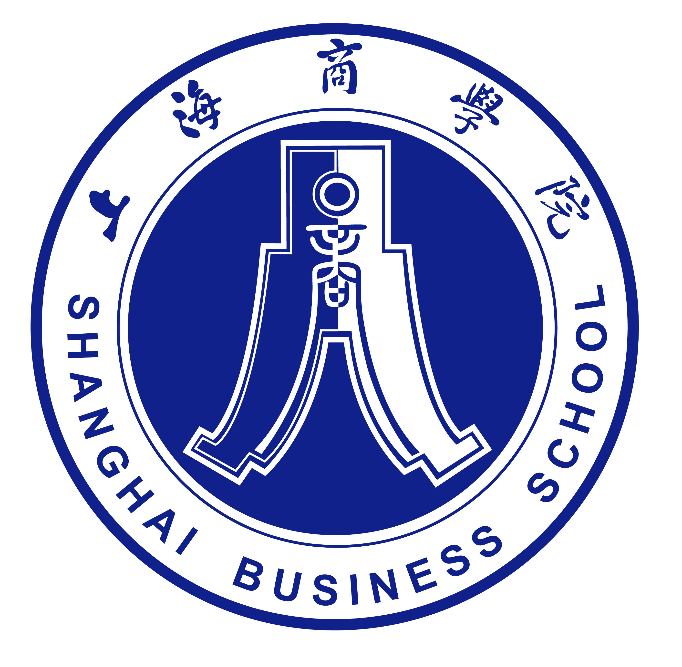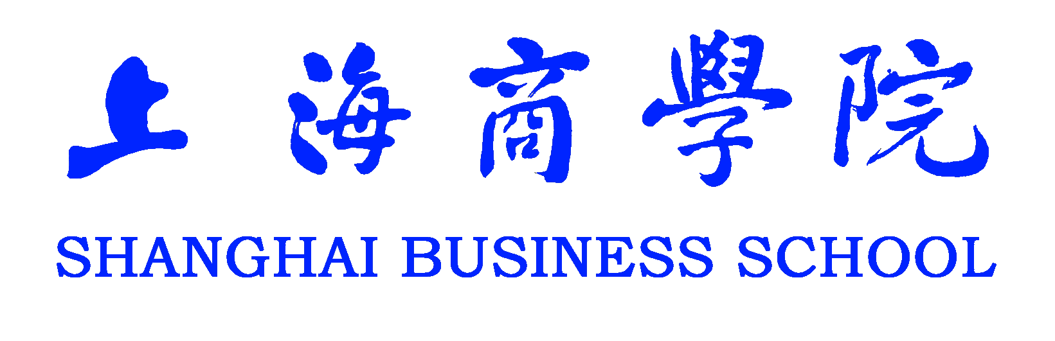

在 读 证 明
学生 ，性别 ，身份证号 ，为上海商学院在读 年制 学生，学号 。该学生自 年9月至今在我校 学院 专业学习，现为大学 年级学生。若取得本专业人才培养方案规定学分，将于 年6月毕业。
上海商学院是教育部批准的具有高等学历教育招生资格的普通高等学校。
特此证明

上海商学院教务处
年 月 日

November,30,2020
Certificate
This is to certify that student （Gender： ）is now studying (student term: years) of higher education in Shanghai Business School. His/Her Identification Card number is and the student number is . The student is enrolled with , majoring in from September to present, and is now in his/her 1st /2nd /3rd /4th year of study. On successfully receiving all the credits required by the curriculum, the student will be allowed to graduate in June .
Shanghai Business School is a university of higher education approved by the Ministry of Education of the People’s Republic of China.
Issued by
Academic Affairs Office of Shanghai Business School

